Reading Graphic Novels
The following Prezi presentations identify the key features of graphic novels and will help you effectively read and analyze this type of text.
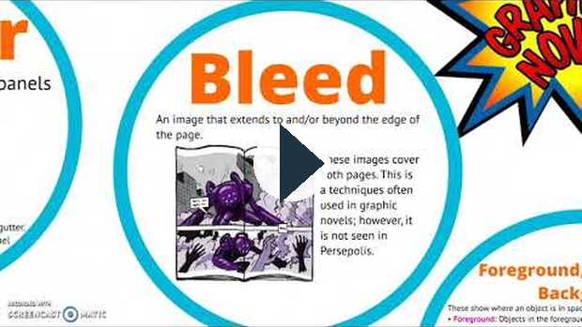
https://www.youtube.com/watch?v=KsPdWcGFyaY

https://www.youtube.com/watch?v=KsPdWcGFyaY

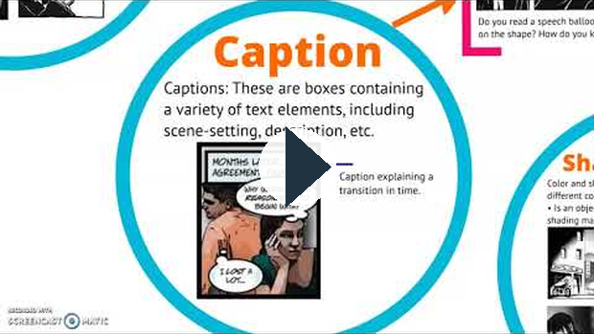
https://www.youtube.com/watch?v=sahdTKF8ABU

https://www.youtube.com/watch?v=sahdTKF8ABU

The following videos are also helpful in knowing how to read graphic novels effectively. The videos may cover some of the information in the Prezi above, but are a little more straight forward than reading through a lot of text.
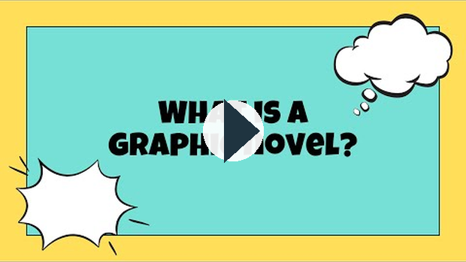
https://www.youtube.com/watch?v=Xe-FYIqrZrI

https://www.youtube.com/watch?v=Xe-FYIqrZrI
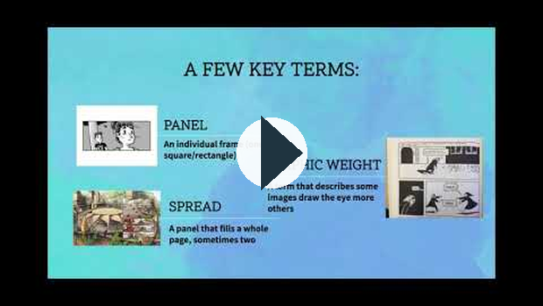
https://www.youtube.com/watch?v=n3waF79jsAI

https://www.youtube.com/watch?v=n3waF79jsAI

Who Was William Shakespeare?
Using the links below, get to know who William Shakespeare was. You will be asked to respond to some research questions in your assignment.

Researching William Shakespeare
- Britannica.com
- Biography.com
- Folger.edu
- Shakespeare.org.uk

Videos to Watch
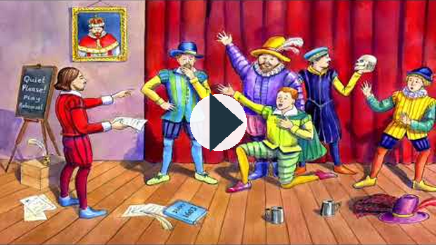
https://www.youtube.com/watch?v=c3RyQxEdPmY
Direct Link:

https://www.youtube.com/watch?v=c3RyQxEdPmY
this link opens in a new window/tab)
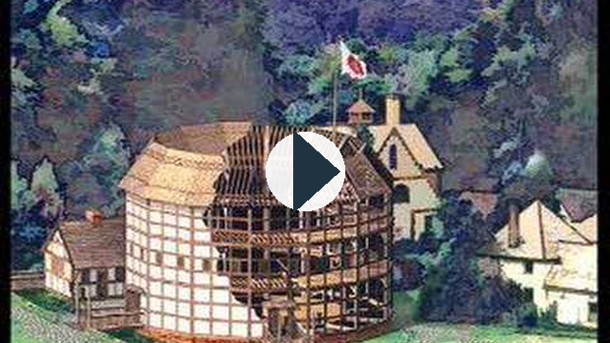
https://www.youtube.com/watch?v=L9t11BsE0yk
Direct Link:

https://www.youtube.com/watch?v=L9t11BsE0yk
this link opens in a new window/tab)
The video below is pretty lengthy but very good:
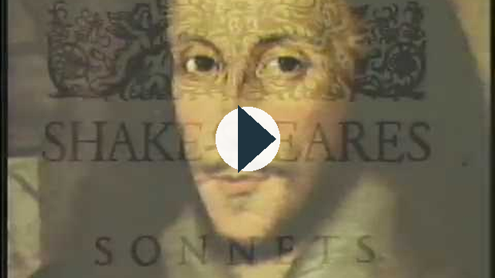
https://www.youtube.com/watch?v=ITc13WnBWX4
Direct Link:

https://www.youtube.com/watch?v=ITc13WnBWX4
his link opens in a new window/tab)
Did You Know?!
Women were not allowed to be stage performers, so young male actors had to disguise themselves in order to perform female roles.
(this link opens in a new window/tab)

Structure of Shakespeare’s Plays
Before you begin reading the play, you need to know that all of Shakespeare’s plays are divided up into 5 Acts, and each Act is further broken up into Scenes.

Purpose of Shakespearean Acts
Act I | - establishes the setting, provides essential information, introduces the characters and their conflicts.
Act II | - continues the action, introduces complications. Characters and their conflicts are fleshed out.
Act III | - the major turning point, or climax in the action occurs
Act IV | - the action begins to “fall”, as do the fortunes of the protagonists. The falling action is usually set into motion by the crisis that arose in Act 3.
Act V | - The final Act of a Shakespearean tragedy marks the tragic failure, and usually the deaths, of the protagonists. The tragic end occurs as a natural outgrowth of the action, the crisis, and the tragic flaws of the protagonists.

Characters in Romeo and Juliet
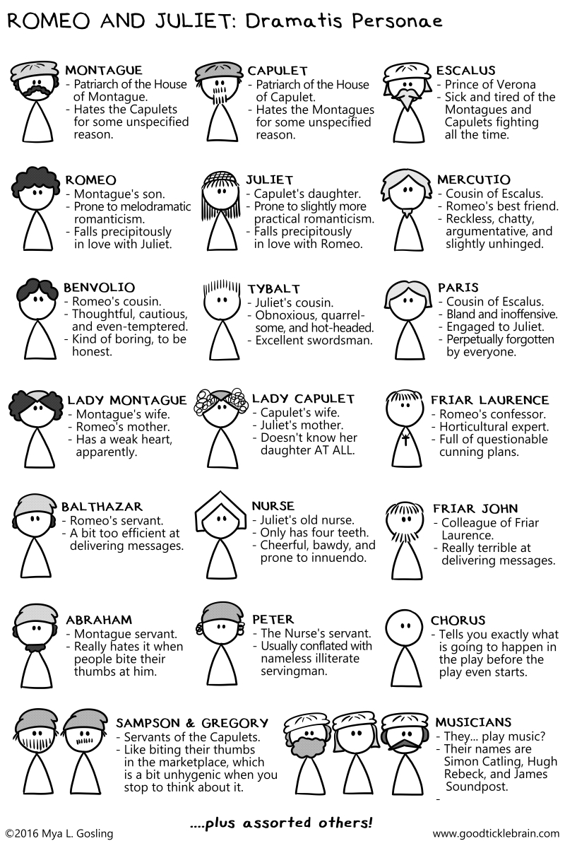

Some Shakespearean Insults
- Thou art as loathsome as a toad.
- Thine face is not worth sunburning.
- Your brain is as dry as the remainder biscuit after voyage.
- Thou poisonous bunch-back’d toad!
(this link opens in a new window/tab)

Studying Shakespeare
In English 10-2, you are expected to comprehend what is happening in a Shakespeare play. The play you will be studying is Romeo & Juliet. You will be expected to sign out a copy of the graphic novel from the school (either cover version works).

Alternative Format
If you are unable to access a copy of the graphic novel, you can also complete the study using the online animated comic. Advance forward to access the video.
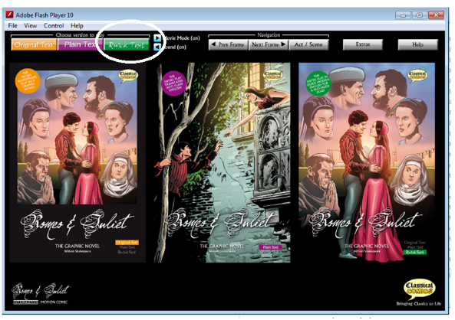
his link opens in a new window/tab)

Act I

Act I Scene I
Supporting file: 02_SUPPORTING_FILES_BY_UNIT/04 - Unit 3 Graphic Novels and Shakespeare/Act I Scene I-03f79a6524.mp4
Original package path: contentservice_objects/68ae0749-c92a-4696-9f9e-457b7d53c81f_latest/hd.mp4

Act I Scene II
Supporting file: 02_SUPPORTING_FILES_BY_UNIT/04 - Unit 3 Graphic Novels and Shakespeare/Act I Scene II-fd2dbc7220.mp4
Original package path: contentservice_objects/71793542-35c7-4980-bf9e-0bfac106ce46_latest/source.mp4

Act I Scene III
Supporting file: 02_SUPPORTING_FILES_BY_UNIT/04 - Unit 3 Graphic Novels and Shakespeare/Act I Scene III-9e6bfc9510.mp4
Original package path: contentservice_objects/4fddd552-3c02-45b2-8486-dde67896645a_latest/source.mp4

Act I Scene IV
Supporting file: 02_SUPPORTING_FILES_BY_UNIT/04 - Unit 3 Graphic Novels and Shakespeare/Act I Scene IV-53c0740bdb.mp4
Original package path: contentservice_objects/1bb7fbd4-796e-4dc1-97dd-fd0735c97508_latest/source.mp4

Act I Scene V
Supporting file: 02_SUPPORTING_FILES_BY_UNIT/04 - Unit 3 Graphic Novels and Shakespeare/Act I Scene V-0b25e9ffc9.mp4
Original package path: contentservice_objects/1c7fa2c6-2142-43ad-a079-68680d7429f8_latest/source.mp4

Act II

Act II Scene I
Supporting file: 02_SUPPORTING_FILES_BY_UNIT/04 - Unit 3 Graphic Novels and Shakespeare/Act II Scene I-2fcac6d39b.mp4
Original package path: contentservice_objects/f37b24aa-77d6-4527-a269-ef2331160b8a_latest/source.mp4

Act II Scene II
Supporting file: 02_SUPPORTING_FILES_BY_UNIT/04 - Unit 3 Graphic Novels and Shakespeare/Act II Scene II-796ae9b03a.mp4
Original package path: contentservice_objects/d105d5ef-045c-4acf-b4db-37786ab92cce_latest/source.mp4

Act II Scene III
Supporting file: 02_SUPPORTING_FILES_BY_UNIT/04 - Unit 3 Graphic Novels and Shakespeare/Act II Scene III-36c739169c.mp4
Original package path: contentservice_objects/9e149753-0305-494c-aa1f-0675c8aa84e2_latest/source.mp4

Act II Scene IV
Supporting file: 02_SUPPORTING_FILES_BY_UNIT/04 - Unit 3 Graphic Novels and Shakespeare/Act II Scene IV-35c5df0e91.mp4
Original package path: contentservice_objects/eb6b1a52-6b57-42a0-8eb0-bfafb5a2e6e4_latest/source.mp4

Act II Scene V
Supporting file: 02_SUPPORTING_FILES_BY_UNIT/04 - Unit 3 Graphic Novels and Shakespeare/Act II Scene V-7da59b106c.mp4
Original package path: contentservice_objects/f78bdb8a-987a-4711-bd4a-68f15bec139d_latest/source.mp4

Act II Scene VI
Supporting file: 02_SUPPORTING_FILES_BY_UNIT/04 - Unit 3 Graphic Novels and Shakespeare/Act II Scene VI-6ce43c05ff.mp4
Original package path: contentservice_objects/b4eca55f-1fef-458d-9bcf-8e2b30d766b2_latest/source.mp4

Act III

Act III Scene I
Supporting file: 02_SUPPORTING_FILES_BY_UNIT/04 - Unit 3 Graphic Novels and Shakespeare/Act III Scene I-6658eacc79.mp4
Original package path: contentservice_objects/1da9a97b-7dad-48a3-85ec-5930d6566178_latest/source.mp4

Act III Scene II
Supporting file: 02_SUPPORTING_FILES_BY_UNIT/04 - Unit 3 Graphic Novels and Shakespeare/Act III Scene II-ef222cfb8d.mp4
Original package path: contentservice_objects/287777f1-07f8-4f46-aec8-47ad56e3af43_latest/source.mp4

Act III Scene III
Supporting file: 02_SUPPORTING_FILES_BY_UNIT/04 - Unit 3 Graphic Novels and Shakespeare/Act III Scene III-2bcc0d4675.mp4
Original package path: contentservice_objects/0a3a14c9-f048-4c68-a710-6a9b0dca8730_latest/source.mp4

Act III Scene IV
Supporting file: 02_SUPPORTING_FILES_BY_UNIT/04 - Unit 3 Graphic Novels and Shakespeare/Act III Scene IV-05cd230836.mp4
Original package path: contentservice_objects/77980f4b-86d2-4b89-910c-a7cab933ac6a_latest/source.mp4

Act III Scene V
Supporting file: 02_SUPPORTING_FILES_BY_UNIT/04 - Unit 3 Graphic Novels and Shakespeare/Act III Scene V-d22762480f.mp4
Original package path: contentservice_objects/7f752f57-db9e-4d3f-a8ee-df2373e18d2f_latest/source.mp4

Act IV

Act IV Scene I
Supporting file: 02_SUPPORTING_FILES_BY_UNIT/04 - Unit 3 Graphic Novels and Shakespeare/Act IV Scene I-cede6ff83b.mp4
Original package path: contentservice_objects/02b772a0-abdf-4d99-90ff-e7a13a15423a_latest/source.mp4

Act IV Scene II
Supporting file: 02_SUPPORTING_FILES_BY_UNIT/04 - Unit 3 Graphic Novels and Shakespeare/Act IV Scene II-8496ab7d9a.mp4
Original package path: contentservice_objects/470325d8-3ec5-4136-8545-63b0a0e04fe6_latest/source.mp4

Act IV Scene III
Supporting file: 02_SUPPORTING_FILES_BY_UNIT/04 - Unit 3 Graphic Novels and Shakespeare/Act IV Scene III-1656421c6b.mp4
Original package path: contentservice_objects/7e317815-5388-491a-b56a-580e6be6b410_latest/source.mp4

Act IV Scene IV
Supporting file: 02_SUPPORTING_FILES_BY_UNIT/04 - Unit 3 Graphic Novels and Shakespeare/Act IV Scene IV-e4d1b07dda.mp4
Original package path: contentservice_objects/29137931-3011-4e31-a8c6-2182eab93ffb_latest/source.mp4

Act IV Scene V
Supporting file: 02_SUPPORTING_FILES_BY_UNIT/04 - Unit 3 Graphic Novels and Shakespeare/Act IV Scene V-7bef5661db.mp4
Original package path: contentservice_objects/fb0adc60-2221-415a-8778-fabc2901c67f_latest/source.mp4

Act V

Act V Scene I
Supporting file: 02_SUPPORTING_FILES_BY_UNIT/04 - Unit 3 Graphic Novels and Shakespeare/Act V Scene I-2ca81d443c.mp4
Original package path: contentservice_objects/e028538a-2758-48bb-9e4b-4d8be3d5ef8f_latest/source.mp4

Act V Scene II
Supporting file: 02_SUPPORTING_FILES_BY_UNIT/04 - Unit 3 Graphic Novels and Shakespeare/Act V Scene II-7b20d21b77.mp4
Original package path: contentservice_objects/d0270e8c-0c40-432f-92e7-8bdf0cc909fc_latest/source.mp4

Act V Scene III
Supporting file: 02_SUPPORTING_FILES_BY_UNIT/04 - Unit 3 Graphic Novels and Shakespeare/Act V Scene III-685116b214.mp4
Original package path: contentservice_objects/6d6ab1b3-2cc7-44c5-b934-824c82a74c56_latest/source.mp4

